Verizon SAP Guidelines
Step 1: Go to Verizon Home Page
Step 2: Click “ERP Portal” (Tab on right side)
Step 3: Click “My Timesheet”
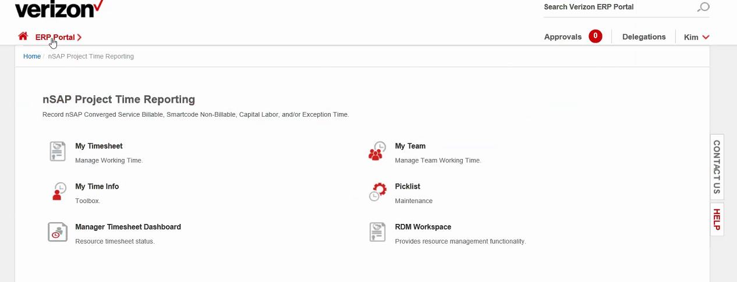
Step 4: Make sure it’s for the correct pay period
Step 5: Click
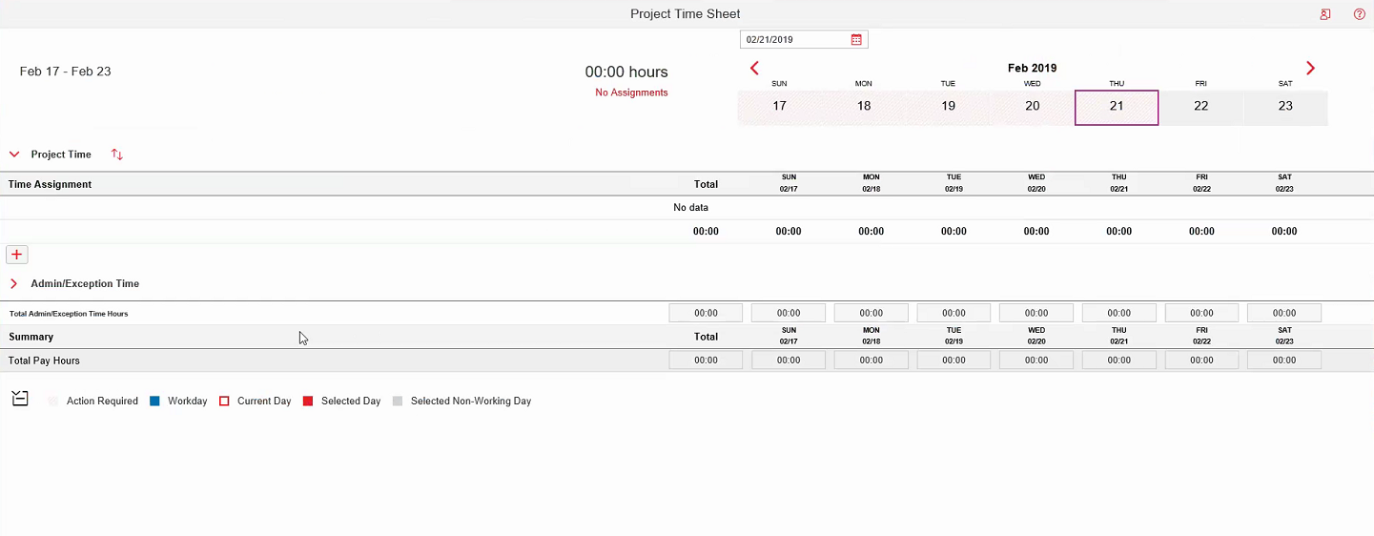

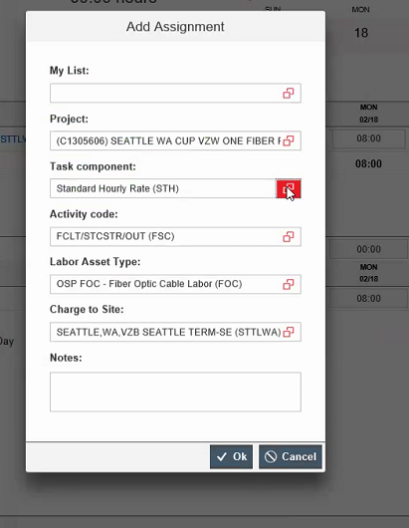

Step 6: Click “Project”
Step 7: Search for your personal project code number
Step 8: Click “My List”
Step 9: Search (different for everyone)
Step 10: Click on the button with project number
Step 11: Activity code (different for everyone)
Step 12: Labor Asset (Same as webtime)
Step 13: Charge to site (click button)
Step 14: “Task component:” should be at Standard Hourly Rate (STH)
Step 15: Click “OK”
Step 16: Enter hours into to total 40 hours for Standard Hourly Rate
Step 17: If you have overtime hours, please follow steps 6-13 again
Step 18: Change “Task component:” to Over Time Hourly Rate (OTH)
Step 19: Click “OK”
Step 20: Enter the additional hours over 40 on the OTH line
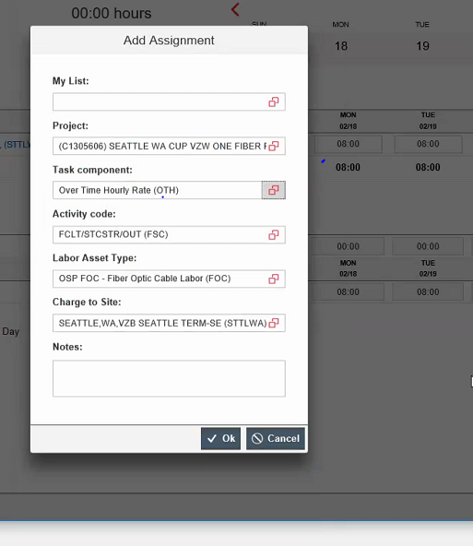
Step 21: Submit Timesheet

